Suppose we wish to calculate $\int_{0.5}^{2.5}{f\left(x\right)dx}$. We will explore what the parts of this integral would look like if divided into two sections using each of our integration rules.

Show the desired integral on the diagram below (graphically only):

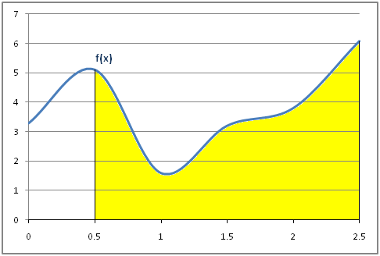

Show the two rectangles that would be used with the **left rectangle** rule (graphically only):

*Note that the each rectangle takes the height (circled point) at the* ***left edge*** *of each section and then* ***goes straight across*** *to form the rectangle.*

Show the two trapezoids that would be used with the **trapezoid** rule (graphically only):

*Note that each trapezoid takes the heights (circled points) at the* ***both edges*** *of the section and then* ***connects them with a line*** *to form the trapezoid.*

For each of the two sections (ranges on *x*-axis for the two rectangles/trapezoids), show the points on the function at the left, right, and middle (graphically only) – these are the points used to create a curve using **Simpson's rule**:

*Note that Simpson's rule takes the heights (circled points) at the* ***midpoint and both edges*** *of each section and then* ***connects them with a curve (parabola, degree 2 polynomial; roughly sketched in below)*** *to form the area.*

First subinterval from 0.5 to 1.5

Second subinterval from 1.5 to 2.5

Area under curve for 2nd-degree polynomial formed by points at left edge, midpoint, and right edge of subinterval:

$Area= \frac{1}{6}\left(f\left(left\right)+ 4*f\left(midpoint\right)+f\left(right\right)\right)*width$

Otherwise, Simpson's rule is the same as the trapezoid or rectangle rules.